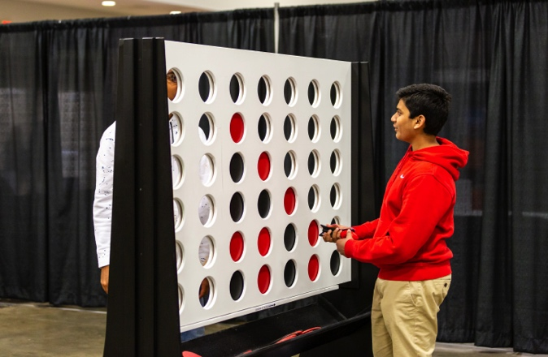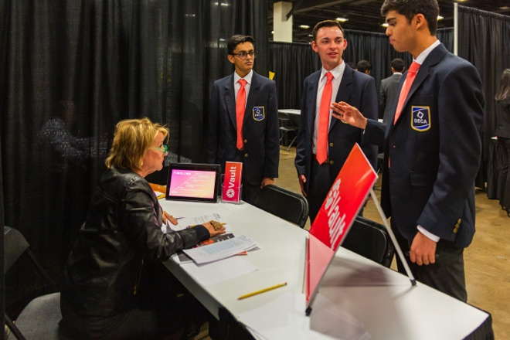

Any information can go here…maybe meeting date/time and some ways to get involved with your chapter. EX:

**THURSDAY, AUGUST 30**

**at 3:30 pm**

GET INVOLVED IN OUR CHAPTER:

* Social Event Here
* Other Chapter Event
* Fall Leadership Here
* District CDC
* State CDC

To change the pictures on the right, right click and select “change picture” and select your own pictures to use!

YOUR SCHOOL HERE