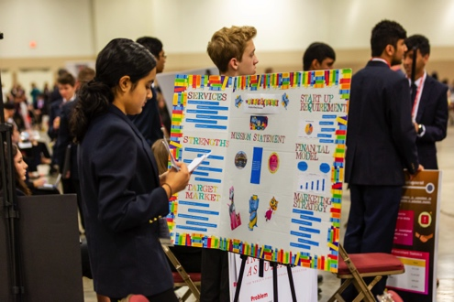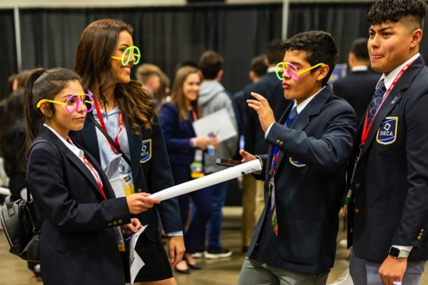

**PRESENTATION TIPS**

**SOCIALS**

**COMPETITION**

**LEARN ABOUT**

Put a description of your meeting here. Everyone wants to know what your meeting will be about. They want to have a little description, which you can put here.

FRIDAY, AUGUST 30

AT 3:30 PM

LOCATION HERE

YOUR CHAPTER NAME HERE